Support for G8 BLOMs

*Products/Programs: G8 Server Blades*

*Target OA release: v3.50 - 2011*

Table of Contents

1 Introduction 4

2 BLOM Characteristics and Assumptions 5

3 Required FRU Support for G8 Blades and BLOMs 6

3.1 Blade Baseboard FRU Support 6

3.2 BLOM Device FRU Support 7

4 CLI Changes 8

5 GUI Changes 11

6 LCD Screen Changes 16

7 DIAG Command Changes 21

8 OA Code Changes 23

9 SOAP Call Changes 24

Revision History

|  |  |  |  |
| --- | --- | --- | --- |
| **Version** | **Date** | **Author** | **Comments** |
| Draft 1 | 10-21-2010 | Jay Brinkmeyer | First draft for internal review. |
| Version 1 | 01-18-2011 | Jay Brinkmeyer | Added introduction text. |
| V1.1 | 02-16-2011 | Jay Brinkmeyer | Added backwards compatibility FRU info. |
| V1.2 | 06-17-2011 | Jay Brinkmeyer | Tweaked naming |
|  |  |  |  |
|  |  |  |  |
|  |  |  |  |

# Introduction

This document describes the OnBoard Administrator support for G8 Server Blade BLOMs in c-Class Blade Enclosures.

Prior to G8 blade release, OA supported server blades with Embedded LOM NICs and up to 7 plug-in Mezzanine Adapters. Server blades were assumed to have at least one Embedded LOM present. OA code assumed that LOM ports were present on every Server Blade. This assumption persisted throughout OA CLI, GUI, LCD and SOAP code.

For G8 blades, the baseboard FRU definition for Mezzes and LOMs was expanded to also include a new “BLOM” Mezz type (also called LOM-DC or BLOMs). This was required to uniquely identify those devices for display and enumeration purposes.

OA for G8 server blades will support mixing G1-G8 blades and FRU formats for Mezzes, LOMs and BLOMs. OA no longer assumes that LOM ports are present or that the ports are Ethernet-only technology type. OA displays new BLOM information and port maps at CLI, GUI, and LCD and provides expanded BLOM information in SOAP calls to VC and other consumers.

# BLOM Characteristics and Assumptions

Each BLOM device is assumed to be a 2-port adapter that can be plugged in place of one Embedded NIC.

OA does not assume that any BLOM cards are present.

BLOM port routing is defined by its FRU. However, it must be identical to that of Embedded NIC LOM ports as defined in G7 and earlier blades.

BLOM FRU defined range is 9-12. This uniquely identifies BLOM devices as different from physical FRUs which range from 1-8.

OA customer visible BLOM numbering ranges from 1-4.

All BLOMs in a given blade must have the **same** technology type and match that of any connected Switches. Otherwise, OA will show mismatched e-keying status.

BLOM technology types are **not** limited to Ethernet.

Various blade types support varying numbers of BLOMs as follows:

* Half-Height blades can have at most **one** BLOM (#1)
* Full-Height / Single-Wide blades have at most **two** BLOMs (#1-2)
* Full-Height / Double-Wide blades (i.e. BL680 Commander) have at most **four** BLOMs (#1-4)

OA will not preclude mixing Embedded NIC LOMs alongside BLOMs in separate “slots”.

OA GUI and CLI display BLOM information similarly to that of physical Mezzanines (see Sample screen shots later in this document).

# Required FRU Support for G8 Blades and BLOMs

## Blade Baseboard FRU Support

Any G8 server blades that support BLOMs must include proper BLOM Port Connectivity entries in their baseboard FRU MREC10h. FRU defined BLOMs range from 9 to 12, which preserves legacy physical Mezz range of 1-8 and Embedded LOMs at Mezz=15.

Figure X below is taken from MREC10h Port Connectivity fields in the baseboard FRU. It shows GBX1 Connector Ports 1-8. A single BLOM “Fxh” is defined which occupies the first two GBX Ports.

To preserve backwards compatibility, the FRU is configured similar to legacy FRUs with the exception of using a “Function Support B” reserved bit to indicate BLOM Support.

OA versions ignore the Function Support B reserved bit and treat BLOM device ports just like Embedded LOM ports. The caveat is that only Ethernet technology type BLOM devices are allowed. This is really just a display issue, not a technical one as any technology type matching SWM ports could be used.

OA versions that recognize “Function Support B” bit 1 (the value 62h shown below) will properly handle BLOM devices. If bit 1 is cleared then the blade uses standard Embedded LOMs the same as legacy blades. If bit 1 is set, BLOM support is enabled then Fxh Embedded LOM ports are decoded using BLOM port numbering as described above.

Note: Current BLOM support does not allow both Embedded LOMs and BLOMs to be enabled at the same time.

|  |  |
| --- | --- |
|  |  |
| 62h | Function Support (b) (Power support: Dynamic, static Low, no reboot, LOM-DC) |
| … |  |
| **F0h** | **GBX1 (upper GBX) Port 1 Connectivity (BLOM1 port 1)** |
| **F1h** | **Port 2 Connectivity (BLOM1 port 2)** |
| 10h | Port 3 Connectivity (MEZZ1 port 1) |
| 11h | Port 4 Connectivity (MEZZ1 port 2) |
| 20h | Port 5 Connectivity (MEZZ2 port 1) |
| 21h | Port 6 Connectivity (MEZZ2 port 2) |
| 22h | Port 7 Connectivity (MEZZ2 port 3) |
| 23h | Port 8 Connectivity (MEZZ2 port 4) |

**Figure X: Baseboard FRU - MREC10h**

## BLOM Device FRU Support

Each BLOM device is required to include a FRU with identical characteristics to current Mezz FRUs.

BLOM FRU DeviceID value present in Baseboard FRU MREC10 is arbitrary to the OA. That is, the DeviceID value sent to iLO to read/write the BLOM FRU can be any value that is supported by iLO.

BLOM FRU E-keying MREC30h values for Product Name, PowerOnWatts and HSSTraceLengths are handled exactly as are those provided by physical Mezzes.

OA supports BLOMs of any technology type that match technology types already supported for other physical Mezzes.

# CLI Changes

* SHOW SERVER INFO XX
* SHOW SERVER PORT MAP XX
* SHOW INTERCONNECT PORT MAP XX

Sample output for modified CLI commands is shown below:

**OA-001301010149> show server info 1**

Server Blade #1 Information:

Type: Server Blade

Manufacturer: HP

Product Name: ProLiant BL480c G8

Part Number:

System Board Spare Part Number: 610096-001

Serial Number:

UUID: 00000000-0000-0000-0000-000000000000

Server Name: [Unknown]

Asset Tag: [Unknown]

ROM Version: I14 03/30/2006

CPU 1: Dual-Core Intel Xeon 3000 MHz

CPU 2: Dual-Core Intel Xeon 3000 MHz

Memory: 1024 MB

Adaptive Mezz 1: BLOM BL620c G8------

Ethernet MAC AM1 Port 1-a: 00:00:00:00:00:01

iSCSI/FCoE MAC AM1 Port 1-b: 00:00:00:00:00:01

Ethernet MAC AM1 Port 2-a: 00:00:00:00:00:04

iSCSI/FCoE MAC AM1 Port 2-b: 00:00:00:00:00:05

Adaptive Mezz 2: BLOM BL620c G8------

Ethernet MAC AM2 Port 1-a: 00:00:00:00:00:01

iSCSI/FCoE MAC AM2 Port 1-b: 00:00:00:00:00:01

Ethernet MAC AM2 Port 2-a: 00:00:00:00:00:04

iSCSI/FCoE MAC AM2 Port 2-b: 00:00:00:00:00:05

**OA-001301010149> show server port map 1**

Mezz

Mezz Mezz Device Port Interconnect Interconnect

Slot Device Port Status Bay Bay Port Device ID

---- ------ ------ ---------- ------------ ------------ ----------------

------------------------------- Blade 001 -------------------------------

1 Not Present

2 Not Present

3 Not Present

AMZ1 BLOM BL620c G8------

Ethernet MAC AM1 Port 1-a OK Bay 1 Port 1 00:00:00:00:00:01

iSCSI/FCoE MAC Port 1-b OK Bay 1 Port 1 00:00:00:00:00:01

Ethernet MAC AM1 Port 2-a OK Bay 2 Port 1 00:00:00:00:00:04

iSCSI/FCoE MAC Port 2-b OK Bay 2 Port 1 00:00:00:00:00:05

AMZ2 BLOM BL620c G8------

Ethernet MAC AM2 Port 1-a OK Bay 1 Port 9 00:00:00:00:00:01

iSCSI/FCoE MAC Port 1-b OK Bay 1 Port 9 00:00:00:00:00:01

Ethernet MAC AM2 Port 2-a OK Bay 2 Port 9 00:00:00:00:00:04

iSCSI/FCoE MAC Port 2-b OK Bay 2 Port 9 00:00:00:00:00:05

**OA-001301010149> show interconnect port map all**

1: Cisco Catalyst Blade Switch 3120X for HP w/ IP Base

Type: Ethernet

Width: Single

Status: OK

Port 1 2 3 4 5 6 7 8 9 10 11 12 13 14 15 16

Status OK OK OK OK OK OK OK OK OK OK

Blade 1 6 7 8 1 10 11 6 6 15A

Mezz/Nic AM1 NI NI NI AM2 NI NI NI NI NI

Port 1 3 1 1 1 1 1 5 1 1

2: HP 1:10Gb Ethernet Blade Switch

Type: Ethernet

Width: Single

Status: OK

Port 1 2 3 4 5 6 7 8 9 10 11 12 13 14 15 16

Status OK OK OK OK OK OK OK OK OK OK

Blade 1 6 7 8 1 10 11 6 6 15B

Mezz/Nic AM1 NI NI NI AM2 NI NI NI NI NI

Port 2 4 2 2 2 2 2 6 2 1

# GUI Changes

**Device Bay Information -> Information Tab screen. Note the AMZ notation.**

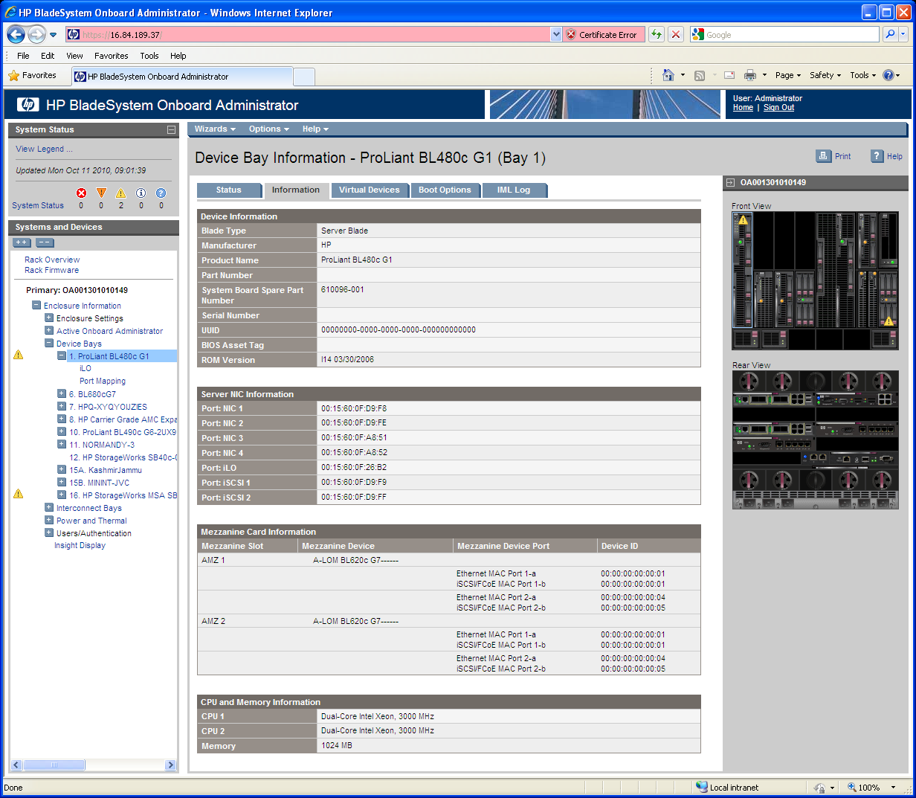

**Device Bay Information -> Port Mapping -> Graphical View. Note the AMZ notation.**

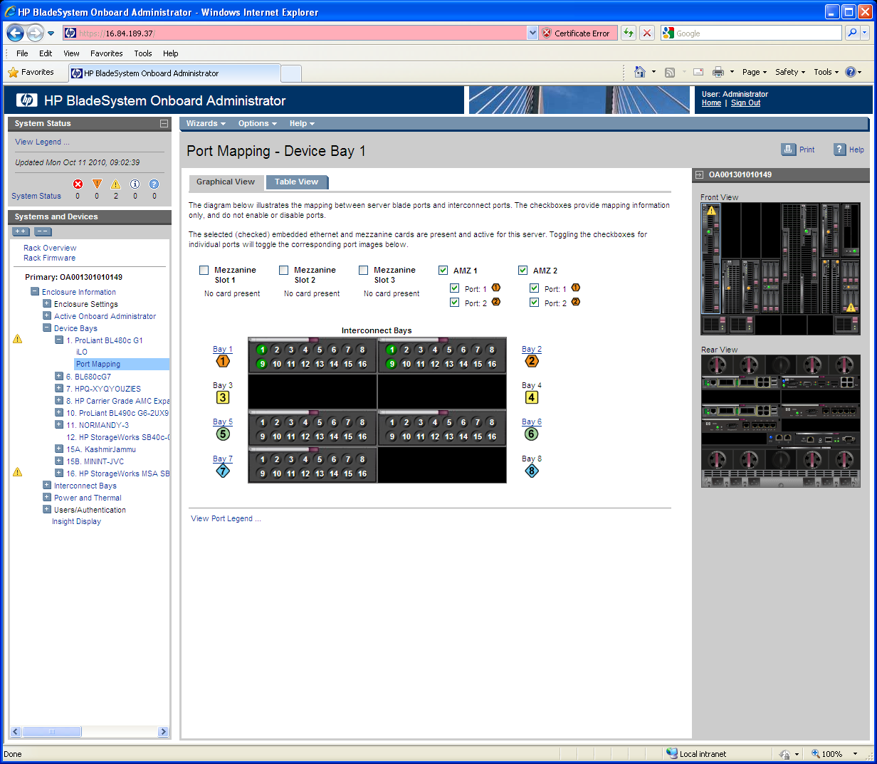

**Device Bay Information -> Port Mapping -> Table View. Note the AMZ notation.**

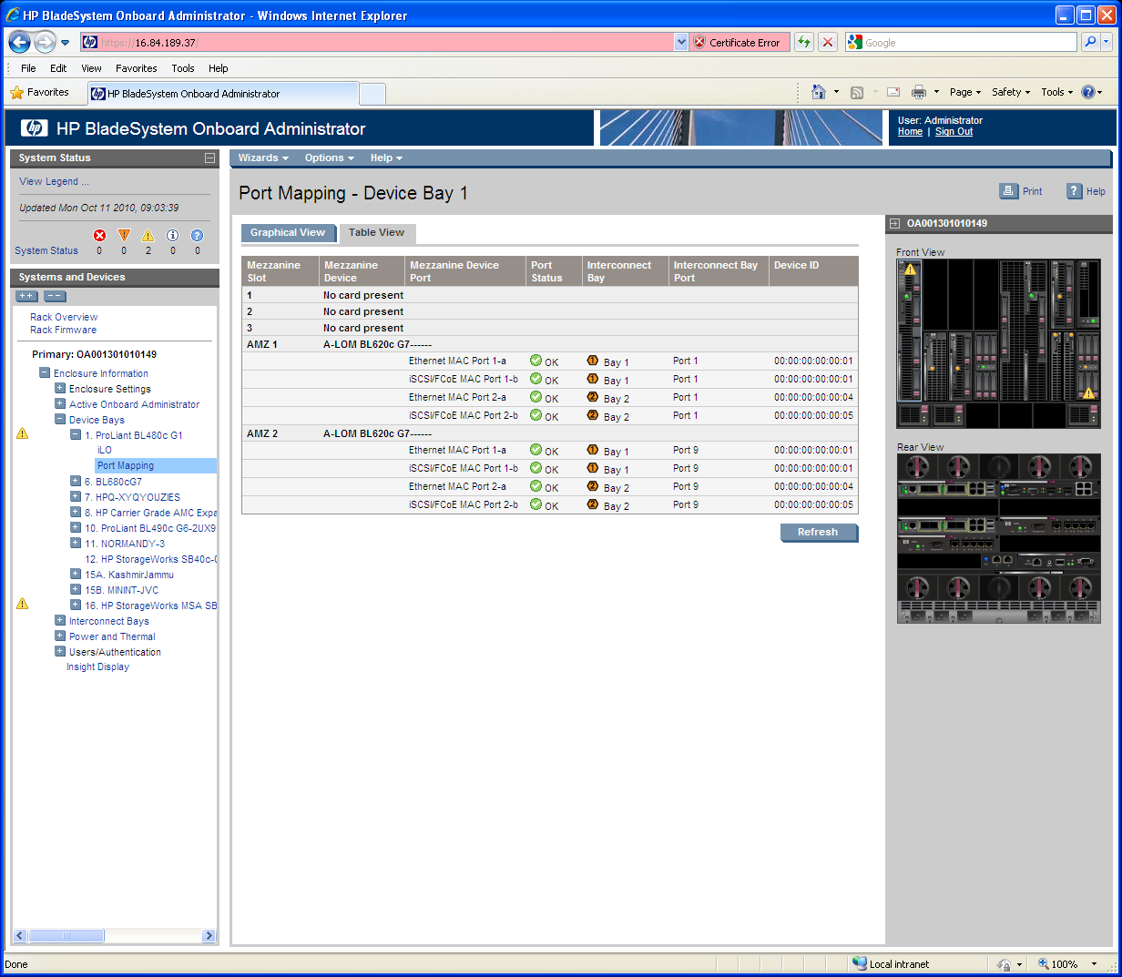

**Interconnect Bays -> Port Mapping . Note the AMZ notation.**

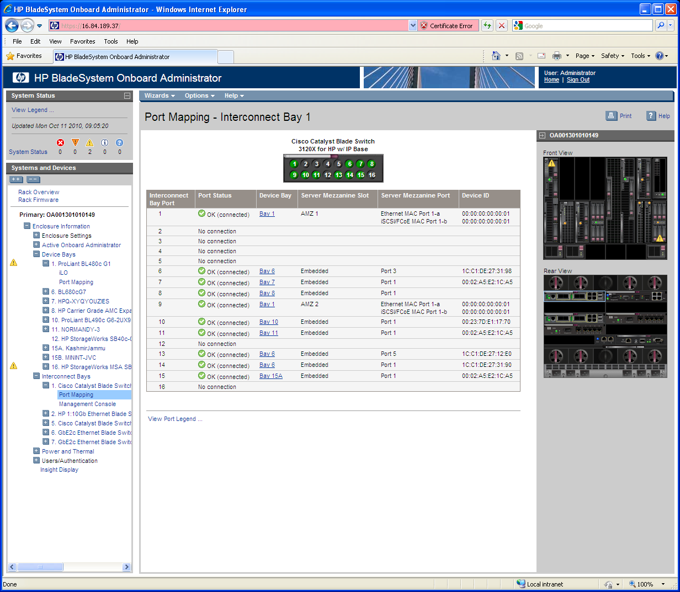

**Interconnect Bays -> Port Mapping. E-Keying Mismatch example (yes, it’s a hack as the BLOM technology type was changed from Ethernet to something else).**

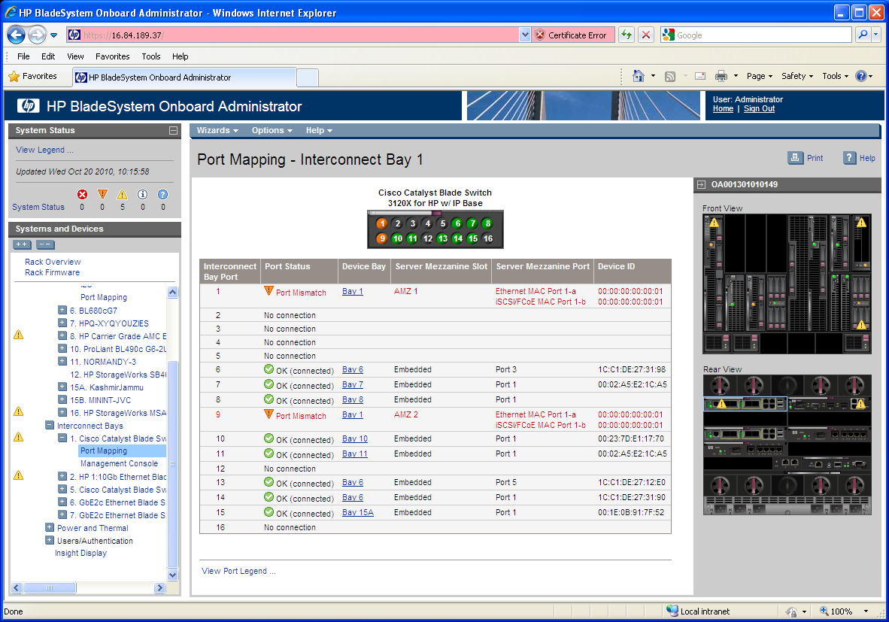

# LCD Screen Changes

Blade or Port Info -> Blade Info. Note that the “More” button is only present if one or more BLOMs are found.

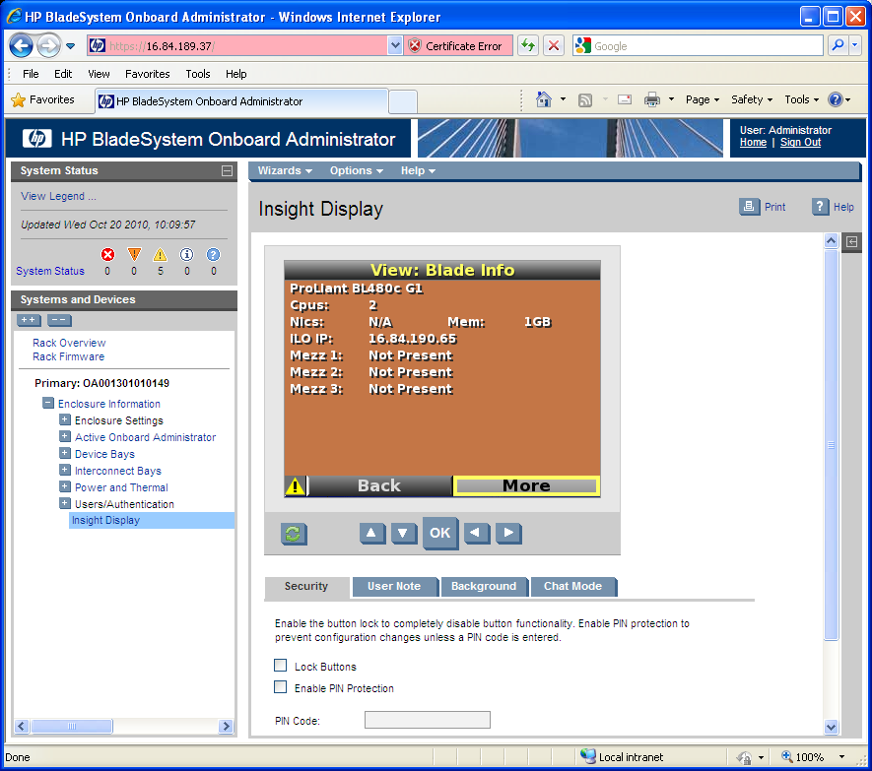

Blade or Port Info -> Blade Info -> More

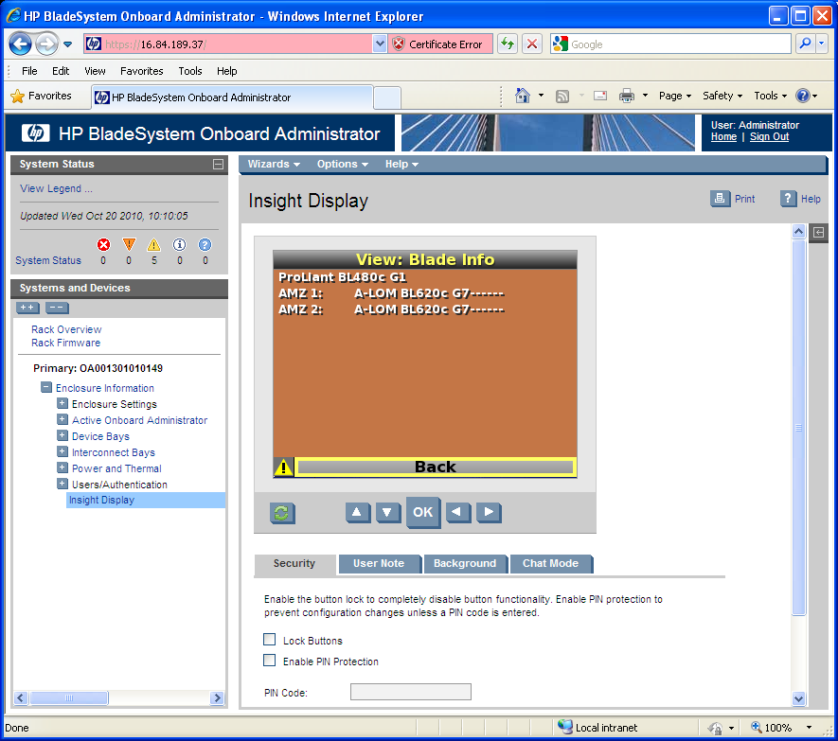

Blade or Port Info -> Port Info

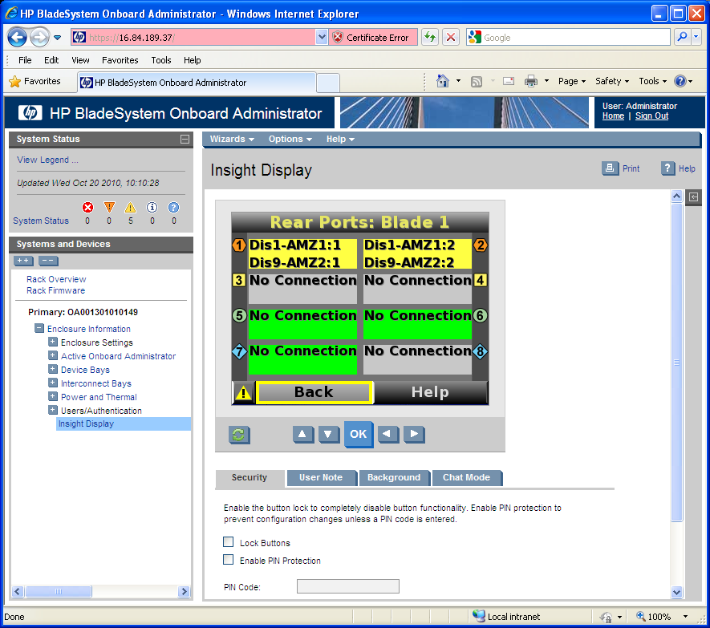

Health Summary -> Config Error -> Details

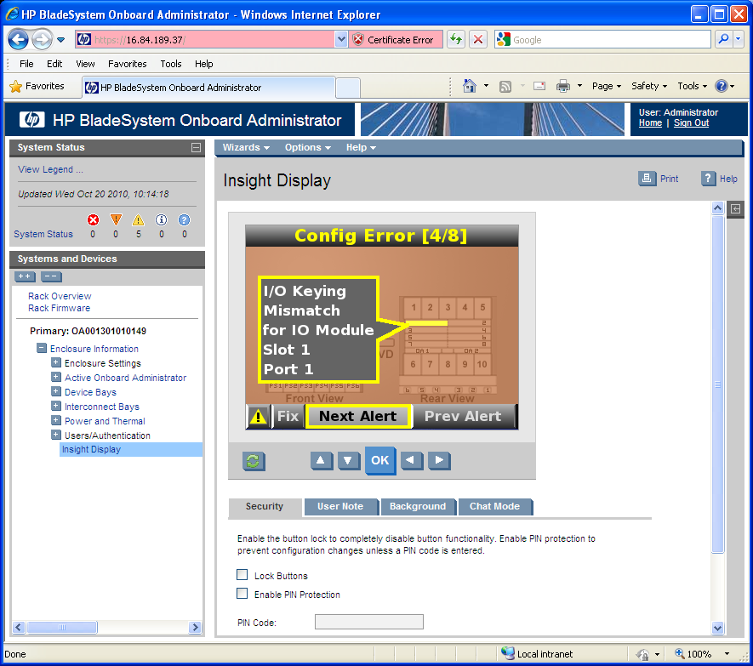

Health Summary -> Fix -> Help

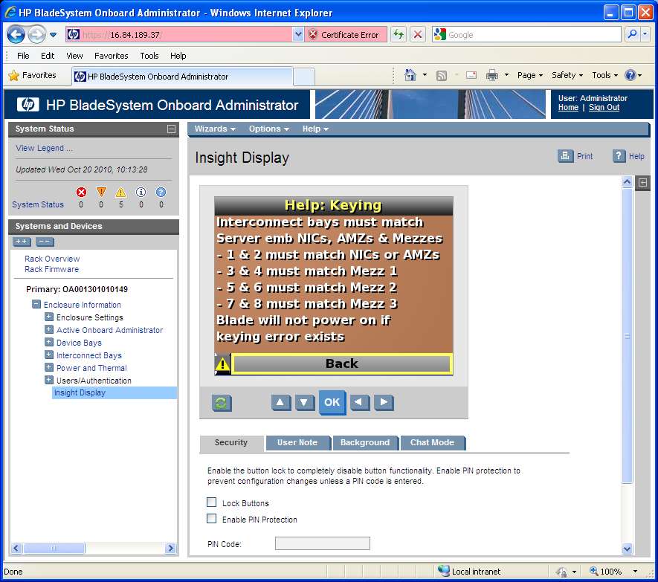

# DIAG Command Changes

* K_BLADE
* B_CLP

**diag> k_blade 1**

Blade 1: <Double> E-keying Status=1 numMezz=3 numLOM=0 numAMz=2

Mezz Slot 1: Not Present

Mezz Slot 2: Not Present

Mezz Slot 3: Not Present

Mezz Slot 9 (AMEZ-1): Type 1

iobay1 ioslot0 vioport1 pioport1

iobay2 ioslot0 vioport1 pioport1

iobay0 ioslot0 vioport0 pioport0

iobay0 ioslot0 vioport0 pioport0

iobay0 ioslot0 vioport0 pioport0

iobay0 ioslot0 vioport0 pioport0

iobay0 ioslot0 vioport0 pioport0

iobay0 ioslot0 vioport0 pioport0

Mezz Dev 9: Prop 0 Type 1 Status 1(OK) Name: A-LOM BL620c G8------

port1: fabric1 (Ether) status1(OK) id->00:00:00:00:00:01 partner 0

port2: fabric1 (Ether) status1(OK) id->00:00:00:00:00:04 partner 0

port3: fabric0 (None) status0(Unknown) id-> partner 0

port4: fabric0 (None) status0(Unknown) id-> partner 0

port5: fabric0 (None) status0(Unknown) id-> partner 0

port6: fabric0 (None) status0(Unknown) id-> partner 0

port7: fabric0 (None) status0(Unknown) id-> partner 0

port8: fabric0 (None) status0(Unknown) id-> partner 0

Mezz Slot 10 (AMEZ-2): Type 1

iobay1 ioslot0 vioport9 pioport9

iobay2 ioslot0 vioport9 pioport9

iobay0 ioslot0 vioport0 pioport0

iobay0 ioslot0 vioport0 pioport0

iobay0 ioslot0 vioport0 pioport0

iobay0 ioslot0 vioport0 pioport0

iobay0 ioslot0 vioport0 pioport0

iobay0 ioslot0 vioport0 pioport0

Mezz Dev 10: Prop 0 Type 1 Status 1(OK) Name: A-LOM BL620c G8------

port1: fabric1 (Ether) status1(OK) id->00:00:00:00:00:01 partner 0

port2: fabric1 (Ether) status1(OK) id->00:00:00:00:00:04 partner 0

port3: fabric0 (None) status0(Unknown) id-> partner 0

port4: fabric0 (None) status0(Unknown) id-> partner 0

port5: fabric0 (None) status0(Unknown) id-> partner 0

port6: fabric0 (None) status0(Unknown) id-> partner 0

port7: fabric0 (None) status0(Unknown) id-> partner 0

port8: fabric0 (None) status0(Unknown) id-> partner 0

**diag> b_clp 1**

>>> Blade 1: xxxxxxBL620c G8------ <<<

Blade 1 mezz F: NOT FOUND

Blade 1 mezz 1: NOT FOUND

Blade 1 mezz 2: NOT FOUND

Blade 1 mezz 3: NOT FOUND

--------------------------------------

A-LOM BL620c G8------

Mezz=9 (AMEZ1) DevID=40h (off=0200h)

--------------------------------------

FIP: 0 (off=021Ch)

PID01: "set netport1 default"

PID02: "exit"

FIP: 1 (off=023Ch)

PID01: "set netport2 default"

PID02: "exit"

--------------------------------------

A-LOM BL620c G8------

Mezz=A (AMEZ2) DevID=40h (off=0200h)

--------------------------------------

FIP: 0 (off=021Ch)

PID01: "set netport1 default"

PID02: "exit"

FIP: 1 (off=023Ch)

PID01: "set netport2 default"

PID02: "exit"

# OA Code Changes

* GUI
  + udog-gui/www/_version_control_folder_/Templates/interconnectPortMapping.xsl
  + udog-gui/www/_version_control_folder_/Templates/guiConstants.xsl
  + udog-gui/www/_version_control_folder_/Templates/bayInfo.xsl
  + udog-gui/www/_version_control_folder_/Templates/bayPortMapping.xsl
  + udog-gui/www/_version_control_folder_/Templates/bayPortMappingGraphical.xsl
* SOAP / GUI
  + udog-apps/hpoa/translate.c
* LCD
  + udog-apps/lcd/lcd/1.scr - added comments
  + udog-apps/lcd/lcd/2.scr - added comments
  + udog-apps/lcd/lcd/3.scr - added comments
  + udog-apps/lcd/lcd/rc/alert0.pp - changed alert verb definition for MEZZ_CARD_MISSING
  + udog-apps/lcd/lcd/rc/alert2.pp - changed alert verb definition for MEZZ_CARD_MISSING
  + udog-apps/lcd/lcd/main.pp - added BLOM display screen definition
  + udog-apps/lcd/lcd/24.scr - added BLOM “Back-More” screen
  + udog-apps/lcd/lcd/70.scr - BLOM display screen (new file)
  + udog-apps/lcd/em_event.c - added support for BLOM state event bits
  + udog-apps/lcd/em_event.h - added support for BLOM state event bits
  + udog-apps/lcd/bytecode.c - added support for BLOM state bc decode bits / comments
  + udog-apps/lcd/bytecode.h - added BLOM device type
  + udog-apps/lcd/msl_bytecode.c - added comments
  + udog-apps/lcd/constants.h - added BLOM device type
  + udog-apps/lcd/strings.h - added BLOM identifiers, help, and buttonrow strings
  + udog-apps/lcd/interpreter.c - added comments
  + udog-apps/lcd/msl_getset.c - added BLOM aware BladeInfo and PortInfo
  + udog-apps/lcd/alert.c - added support for BLOM alert bits
  + udog-apps/lcd/alert.h - added BLOM location item field
  + udog-apps/lcd/varmap.h - opened hole for BLOM strings
* CLI
  + udog-apps/cli2/show.c - BLOM aware output
  + udog-apps/cli2/events.c - BLOM aware
  + udog-apps/cli2/locationdb.c - Rename vars to make distinct from LCD
  + udog-apps/cli2/locationdb.h - Rename vars to make distinct from LCD
  + udog-apps/cli2/show_interconnect.c - BLOM aware output
* MGMT
  + udog-apps/mgmt/ilo_ribcl.c - array index #define
  + udog-apps/mgmt/keying.c - added BLOM MREC30h parsing, tweaked K_MAP output
  + udog-apps/mgmt/keying.h - added BLOM number to ServerBladeInfo struct
  + udog-apps/mgmt/blade.c - BLOM looping. isBladeWithDynamicPorts var check
  + udog-apps/mgmt/keying_api.c - populate BLOM changes
  + udog-apps/mgmt/keying_api.h - remove Embedded string #define
  + udog-apps/mgmt/blade_ipmi.c - debug
  + udog-apps/mgmt/storage.c - expanded Mezz range
  + udog-apps/mgmt/environ.h - BLOM defines, new Mezz defines
  + udog-apps/libem/em.h - numLOMMezzes, numAMezzes

# SOAP Call Changes

SOAP Commands support expanded Mezz Range: Physical Mezzes 1-8, BLOMs 9-12, Embedded LOM at 15.

* getBladeMezzInfoEx
* getBladeMezzInfoExArray
* getBladePortMap
* getBladePortMapArray
* getBladePortMapWithClpInfo
* getBladePortMapWithClpInfoArray
* getBladeClpStatus